**Changes to Monitoring + Pledging Treatment**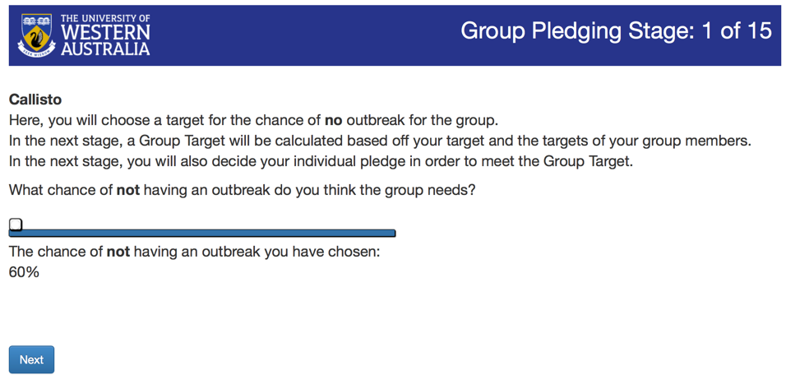

**Suggested modified text:**

Please propose a target level of protection that the group should aim for over the next three rounds. The group target is a value between 13% and 100% and represents the chance that an outbreak will **not** occur.

What chance of an outbreak **not** occurring do you think the group should aim for?

“Slider”

The chance of an outbreak **not** occurring that you have chosen is:

**Suggested modified text:**

Based on the proposal of each player, the target for the group over the next three rounds is:

87.0% 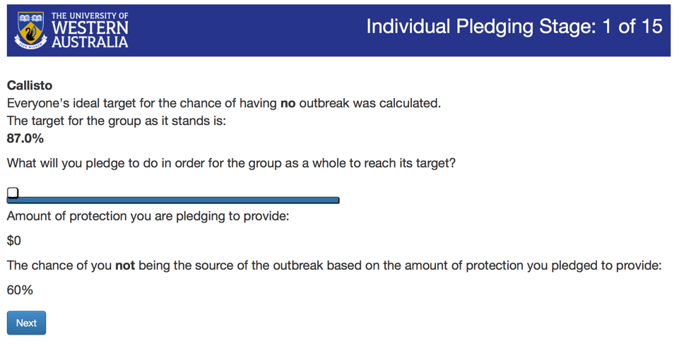

How much effort do you pledge to invest in protecting your crops in order for the group as a whole to reach this target?

“Slider”

The chance of you not being the source of an outbreak based on the amount of protection you pledged to provide is:

**Suggested modified text:**

Please change “you’re” to “you are” beneath the effort slider.

Please change “till” to “until” above the pledge summary table.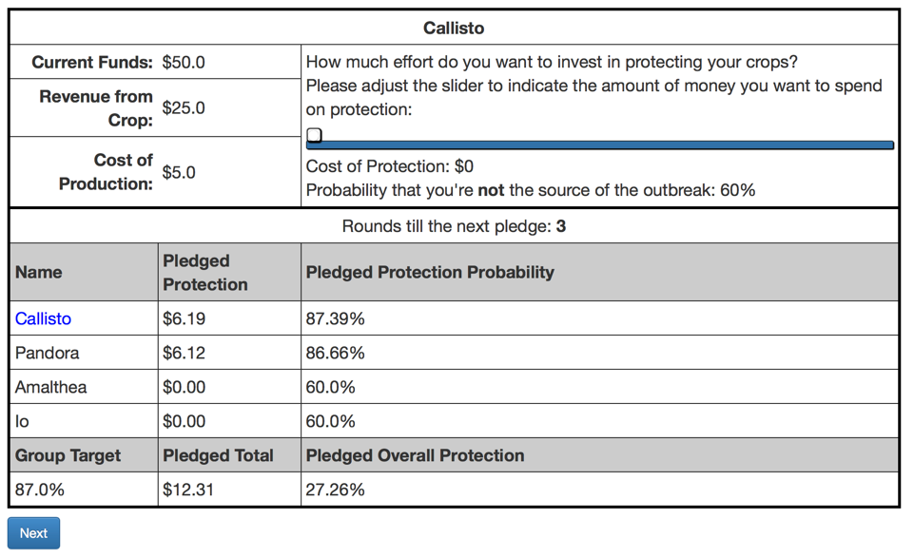

**Suggested modified text:**

Please change “Results of Round 1” to “Round 1 Pledges and Contributions”.

Please change “Cost of Protection” in column 4 to “Actual Protection”.

Please change “Pro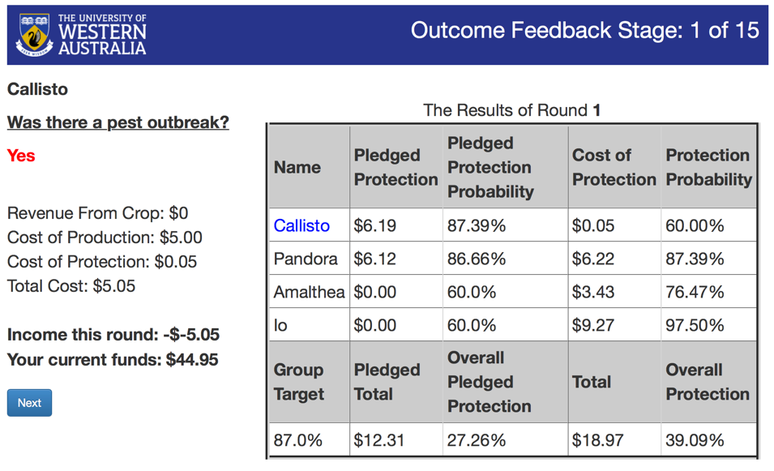tection Probability” in the final column to “Actual Protection Probability”.

**“Round 1 Contributions”**

As in other versions of the program, “Income this round” includes a double negative.